**Stored Procedure**

-- Here, we are going to see –

What is a procedure?

Purpose of using a procedure?

How to create a procedure?

Procedure with parameters?

Procedure without parameters?

How to execute a procedure?

1. What is a procedure?

-- Procedure is a block of code which is given a name and is stored in the database.

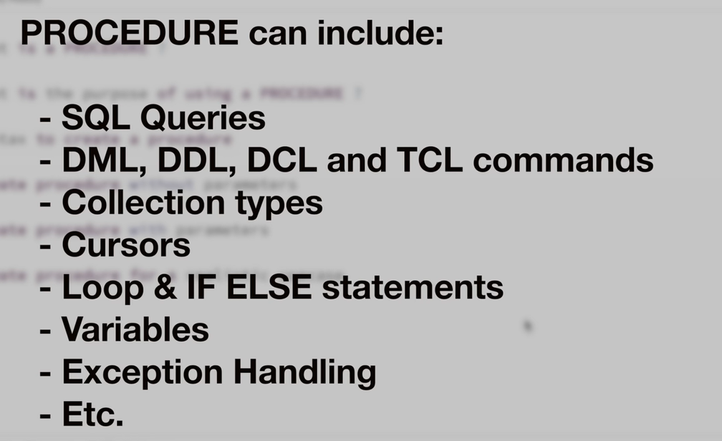

-- Procedures can not only to be used to query data from tables, but we can use procedures to build complex logics, data validations, data clean ups and much more.

-- And this is the reason why procedures are so powerful since we can do a lot using a procedure than using a sql query.

1. Purpose of Using a Procedure

-- Procedure was introduced to give more power to SQL language.

-- Procedures are generally used to do things that are generally not possible in SQL queries.

-- Depending on the project requirements, one can procedure just to bundle multiple queries inside it, or one can build entire software logic inside a procedure which may include validation checks, data processing, querying of data etc.

-- In the simplest of words, we use procedures when we have requirement which is not possible to achieve just by using SQL queries.

1. Syntax to Create a Procedure

-- The PostgreSQL syntax is as follows:

CREATE OR REPLACE PROCEDURE pr_name (p_name VARCHAR, p_age INT)

LANGUAGE plpgsql

AS $$

DECLARE

Variable

BEGIN

PROCEDURE body (all the logics are here)

END;

$$

-- Now, the use of the ‘$$’ symbol is – If you have any single quotation parameter inside your procedure, then you would have to handle each single quote manually by applying escape sequence character and all.

-- For example,

SELECT ‘I’m Ketan’

> SELECT ‘I’’m Ketan’;

> SELECT E‘I\’m Ketan’;

-- So, this is handy if you have one or two quotes to replace.

-- But if your procedure has multiple such single quotes, then this would cause a problem.

-- And that is why another way to do this is –

> SELECT $$’I’m Ketan’$$;

1. Procedure with Parameters